Database Management System Project Report

FastTrack - University Carpool Management System

1. Introduction (Aim or Motivation)
FastTrack is a web-based Carpool Management System designed specifically for university students. The primary aim is to address the challenges students face with expensive and unreliable transportation to and from campus. By creating a trusted platform, students who own vehicles (Drivers) can share rides with those needing transportation (Passengers), thereby sharing travel costs and reducing traffic congestion around the campus.

2. Background (Research & Project Selection)
University students often commute from various parts of the city, leading to high transportation costs and heavy campus traffic. Our research indicated a need for a centralized, student-only carpooling platform. Existing public transportation can be inflexible, while commercial ridesharing apps are often too expensive for daily student use. The project was selected because it provides a practical solution to a real-world problem, emphasizing cost-sharing, environmental benefits, and community building among students.

3. Project Specification
Technologies Used:
- Front-End: HTML5, CSS3, Jinja2 Templates
- Back-End: Python 3.x, Flask Framework
- Database: Oracle Database XE 21c (using python-oracledb driver)
- Environment: Docker and Docker Compose

Users of the System:
- Admin: Manages approvals and handles system-wide complaints.
- Driver: Posts rides, manages ride lifecycle, and earns through the wallet.
- Passenger: Searches for rides, books seats, and makes payments.

4. Entity Relationship Diagram (ERD)
The Entity-Relationship Diagram (ERD) defines the structural architecture of the database, consisting of 11 tables including students, rides, bookings, payments, ratings, notifications, and user_wallets. It outlines relationships such as one-to-many (e.g., driver to rides) and many-to-many relationships resolved via associative tables (e.g., bookings linking students and rides).

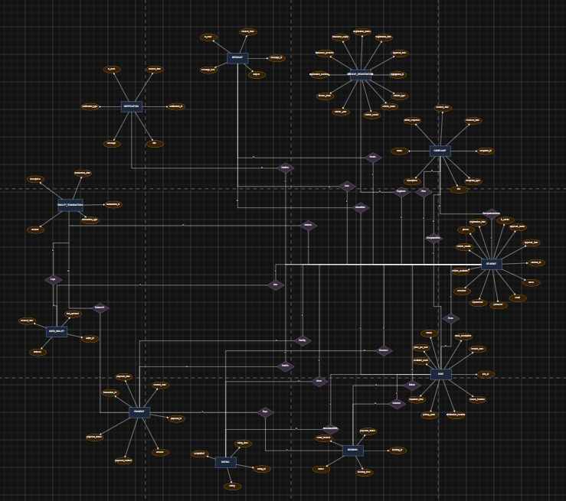

5. Normalization
The database schema has been normalized up to the Boyce-Codd Normal Form (BCNF) to eliminate data redundancy and ensure data integrity.
- 1NF: All attributes are atomic. Multi-valued attributes like vehicle details are structured appropriately without repeating groups.
- 2NF: No partial dependencies exist. All non-key attributes depend fully on the primary key (e.g., booking details depend solely on booking_id).
- 3NF: Transitive dependencies have been removed. For example, wallet balances depend directly on wallet_id rather than intermediate student details.
- BCNF: Every determinant is a candidate key, enforced via strict primary/foreign key constraints.

6. Problem Analysis
Current commuting solutions pose significant financial burdens on students. Security is also a prime concern when matching with random drivers via public social media groups. FastTrack solves this problem by restricting access exclusively to verified university students through an admin-approval workflow. This ensures a safe, trusted, and economical peer-to-peer commuting network.

7. Solution Design (Project Detail, Functionality and features)
The system architecture follows a client-server model utilizing a web interface and a robust Oracle relational database. Key features include:
1. Secure User Registration & Admin Approval Workflow.
2. Ride Management (Posting, Searching, Booking, Lifecycle Tracking).
3. Digital Wallet System for in-app simulated payments and balance tracking.
4. Mutual Rating and Review System (1 to 5 stars).
5. In-App Direct Messaging and Notifications.
6. Automated Ride Status Updates (Status automatically changes to COMPLETED upon departure time).
7. Complaint Management System for conflict resolution.

8. Implementation & Testing phase
Implementation was carried out iteratively. The database was designed first with tables, sequences, triggers, and views in Oracle SQL. The Flask backend was developed to handle routing and database connectivity using python-oracledb. Front-end views were rendered via Jinja2 templates.
Testing involved unit testing of endpoints, manual integration testing of user workflows (e.g., Driver posts ride -> Passenger books -> Driver starts ride -> Passenger pays -> Driver completes ride), and verifying constraints and triggers directly within the Oracle Database.

9. Project Breakdown Structure
The workload was distributed over a 5-week timeline:
- Week 1: Requirement gathering, UI wireframes, and initial ERD design.
- Week 2: Database schema creation (Oracle).
- Week 3: Backend logic (Flask) and database integration.
- Week 4: Frontend implementation (HTML/CSS) and dynamic templating.
- Week 5: Docker containerization, comprehensive testing, and report documentation.

10. Results
The final product successfully implements all defined core functionalities. The platform runs smoothly within Docker containers, providing a seamless user experience from registration to ride completion

Home Dashboard:
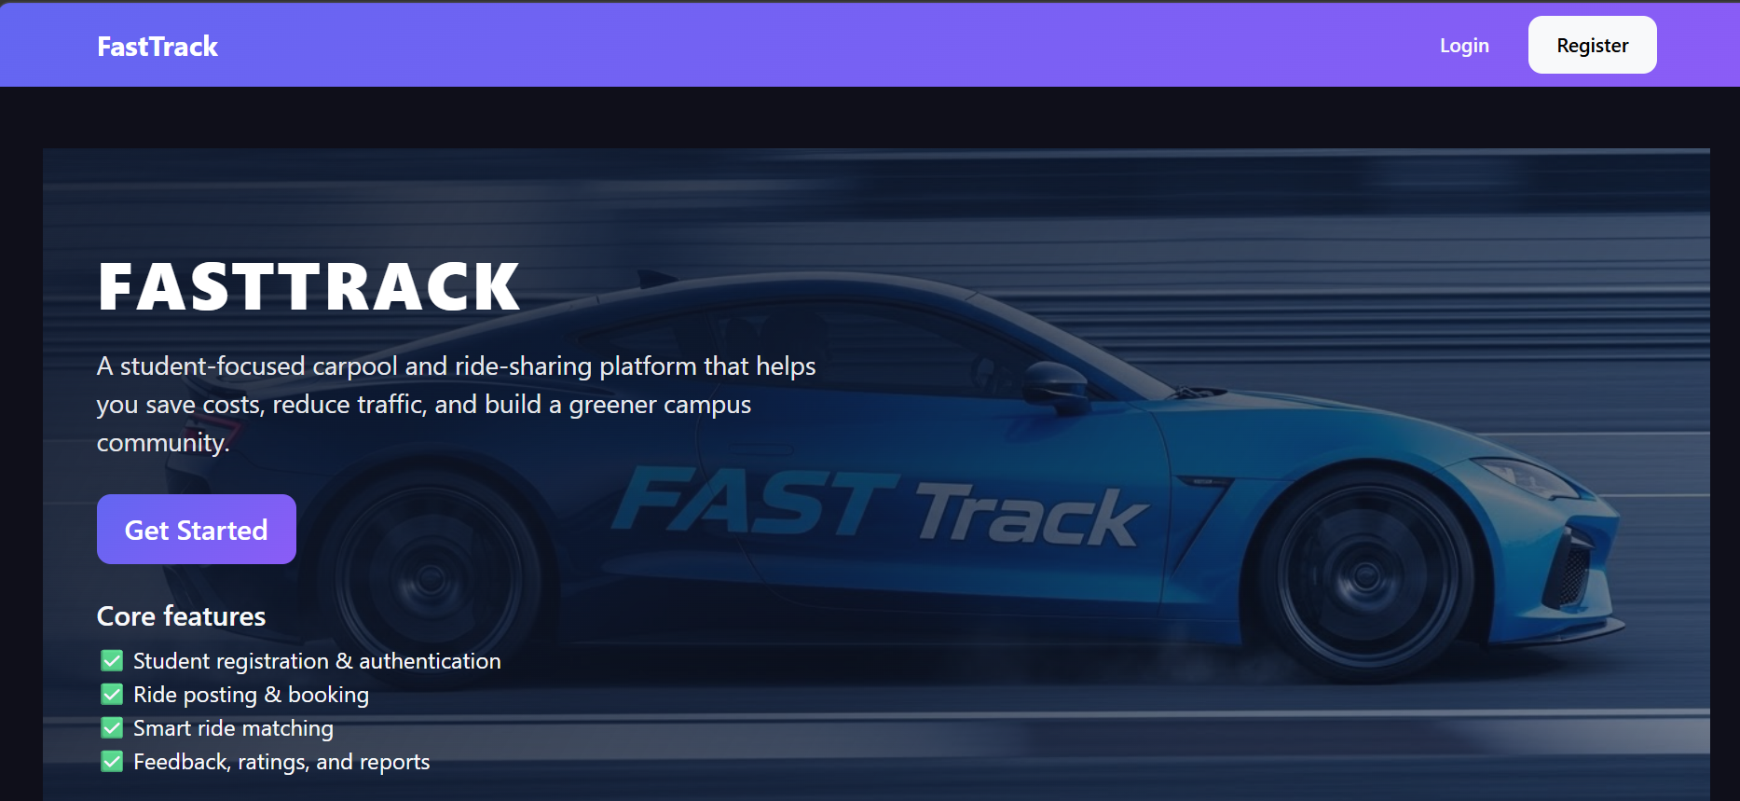

Wallet:
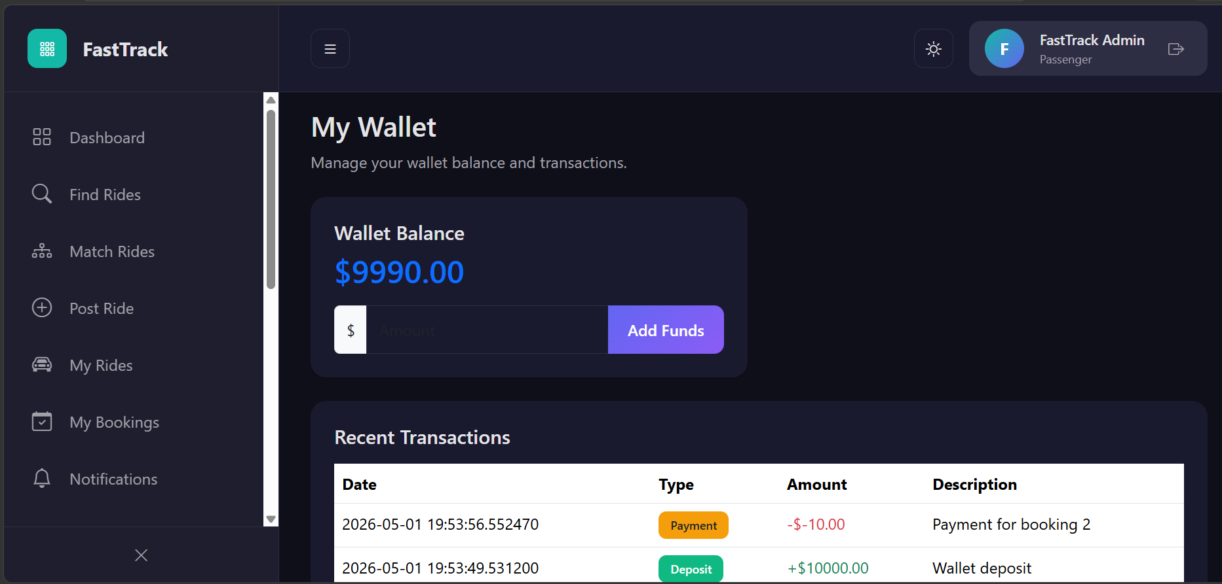

11. Conclusion (Summary & Discussion)
The FastTrack Carpool Management System successfully fulfills its objective of providing a reliable, cost-effective, and safe commuting platform for university students. By integrating a digital wallet, comprehensive rating system, and automated lifecycle management, the project demonstrates a robust, full-stack database application capable of solving real-world transportation issues.

